Consider the following data, decision boundary, and margin boundaries.

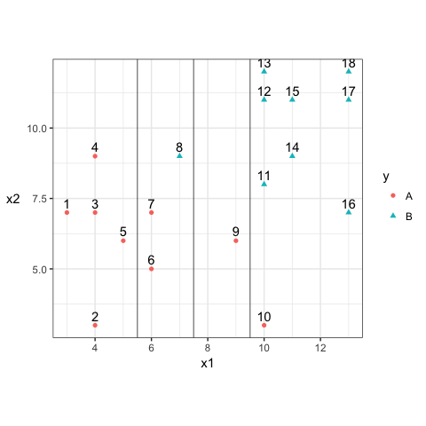

1. Construct the decision rule according to this classification boundary. How would you classify a new observation that has $x_1=6$ and $x_2=10$?

Based on the current classifier, the new observation would be classified as A.

1. What size is the margin here?

The margin size is approximately 2.

1. Which observations receive a penalty? Which observations are the support vectors?

6, 7, 8, 9, 10 receive a penalty and all of them are support vectors.

1. What is the total penalty here?

The total penalty is 5.75.

1. Can I choose a bigger margin if my total allowable penalty is 6?

Yes, the maximal margin cannot allow a total penalty that exceeds the allowable boundary. The current total penalty haven’t exceeded 6 yet. Therefore, the margin can be bigger.

1. Are the data separable? If so, what are the support vectors?

Answer: Yes, the data are separable. 4, 8, and 9 could be the support vectors.